**Chapter 1 – Configuring Hardware Exercises**

1.1 Creating a new project and Setpoint Configuration 3

1.1.1 Create a new TIA Portal Project from the Portal view. 4

1) Create a new project using the Portal view. 4

1.1.2 Add a PLC to the project using “Add new device” 5

1) Add an Unspecified S7 1500 PLC to the project from the Portal view 5

1.1.3 Use the “Detect” function to detect and upload the 1500 local configuration. 6

1) Use the “Detect” function to detect and upload the S71500 local station configuration. 6

1.1.4 Parameterize the Hardware 7

1) Parameterize the CPU communications ports, activate the Clock byte, and set the time zone. 7

2) Parameterize the Analog Input module AI 8xU/I/RTD/TC. 8

1. In the Device view, select the Analog Input module AI 8xU/I/RTD/TC for editing. 8

2. In the Inspector window, select the Properties tab. Expand the branch labeled “Module parameters, Channel template, Inputs.” 9

1.2 Download a Setpoint Configuration 12

1.2.1 Download the hardware configuration to the PLC. 14

1) Download the setpoint configuration to the PLC. 14

## 1.1 Creating a new project and Setpoint Configuration

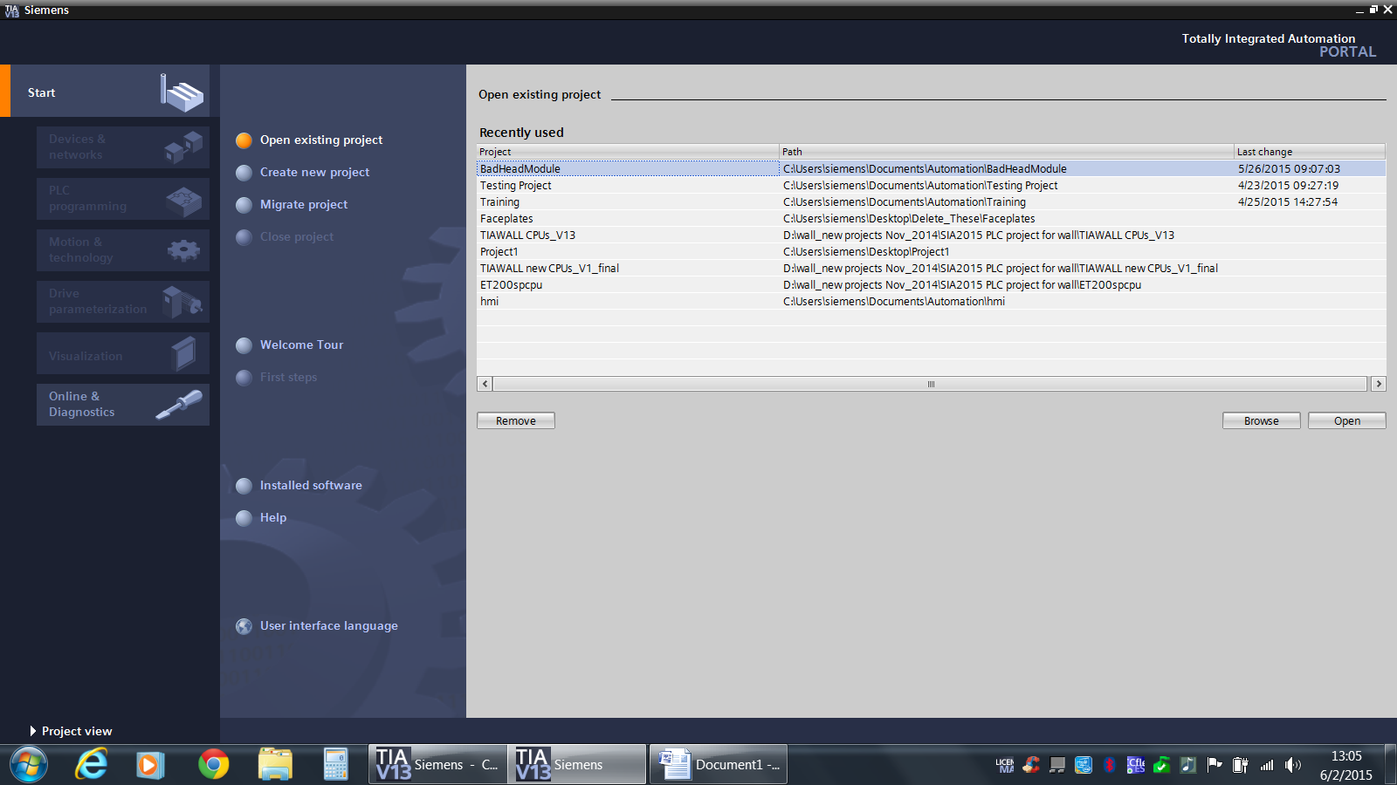

**Description**

The first step in creating a PLC configuration and program is to create a project container. This exercise will guide the user through the steps of creating a new project and adding PLC hardware components.

**Objectives**

Upon completion of this exercise, the student shall be able to:

* Create a new TIA Portal project from the Portal view.
* Add a PLC to the project using “Add new device”
* Use the “Detect” function to detect and upload the 1500 local configuration.
* Parameterize the Hardware

**Prerequisites**

The following prerequisites must be met before this exercise is started:

* The 1516F-3 CPU has been set to default (factory) values.
* An Ethernet connection exists between your PG/PC and the PLC.

1. Create a new TIA Portal Project from the Portal view.

|  |
| --- |
| 1. Create a new project using the Portal view. 2. Open the TIA Portal by using the desktop shortcut, or by selecting “Start”, “TIA Portal V13” from the Windows Start Menu. 3. The Portal view will open to the Start screen and will show a set of tasks. 4. Select “Create a new project”.      1. In the fields to the right, enter “**Training**” as the Project name. Accept the default storage path. 2. Enter **your name** as the Author and enter a comment if desired. 3. Click “Create” to create the new project.   RESULT – a new project is created, and the Portal now shows “First steps”. |

1. Add a PLC to the project using “Add new device”

|  |
| --- |
| 1. Add an Unspecified S7 1500 PLC to the project from the Portal view 2. With “First steps” selected in the Portal view, click on the task labeled “Configure a device” from the choices on the right 3. Note that the view has now changed to the “Devices and networks” portal. Click “Add new device” to open the “Add new device” portal.      1. Select the Controllers button to bring up the list of supported PLC CPUs. 2. Drill down into the catalog of devices under S7-1500, then CPU, then “Unspecified CPU 1500”. Select the only available controller listed with catalog number **6ES7-5XX-XXXXX-XXXX**. Make sure the version is 1.7. 3. Accept the default name “PLC_1”. 4. Make sure the “Open device view” is selected, then click “Add”   RESULT – a placeholder S7-1500 PLC CPU is added and the Project view opens to Devices and Networks with the Device tab selected, showing the object just added.   1. Save the project by clicking “Save project”. |

1. Use the “Detect” function to detect and upload the 1500 local configuration.

|  |
| --- |
| 1. Use the “Detect” function to detect and upload the S71500 local station configuration. 2. Make sure you have an Ethernet cable connected between your PG and the demo hardware. 3. In the previous objective, an unspecified CPU was added, and the option to open the device view was selected. If you forgot to select this option, change to the Project view using the hyperlink in the Portal view. From the Project tree, expand the branch labeled “PLC_1, and then double click on the “Device configuration” entry on the project tree. 4. Note the yellow box informing you to either configure or detect the PLC.      1. Click the “detect” hyperlink to open the hardware detection dialog for the 1500 PLC. Select PN/IE as the “Type of the PG/PC interface”, and select the proper NIC from the “PG/PC interface” pull-down. If you are unsure which NIC to use, ask your instructor. 2. Click the “Start search” button to query the network for attached devices.      1. Note that the software has detected a 1500 on the network. The lack of an IP address shows the device is reset to factory defaults.      1. Select the PLC and click the “Detect” button. After a brief delay, the new configuration opens.      1. Save your project. |

1. Parameterize the Hardware

|  |
| --- |
| 1. Parameterize the CPU communications ports, activate the Clock byte, and set the time zone. 2. In the Device view, select the right hand Profinet ports (2 port switch) on the CPU indicated by the name PROFINET Interface_1. 3. In the Inspector window, select the Properties tab. Under the General tab, select “Ethernet addresses”.      1. Note that “Set IP address in the project” is selected by default. Verify the IP address of the port is set to 192.168.0.1 with a subnet mask of 255.255.255.0. There is no need to add a subnet at this time. 2. Next, select the other Ethernet port of the CPU labeled PROFINET Interface_2. Note that this port has a completely separate and independent IP address. Accept the default of 192.168.1.1 and mask of 255.255.255.0. 3. Next, select the CPU itself from the Device view. 4. Under “General”, scroll down to “System and Clock memory”. 5. Enable the use of the System memory bits by selecting the check box. Assign memory Byte 1 to the system byte. 6. Enable the Clock memory by selecting the check box. Assign Memory byte 0 to the clock byte.      1. Under “Time of day”, set the Time zone to “(UTC-05:00) Eastern Standard Time (USA and Canada)”. 2. Enable Daylight savings time changeover. Accept the default difference of 60 minutes. 3. Leave the Start and End dates at their defaults.      1. Select the “Protection” property. Under the PLC Access level settings, select “Full access incl. fail-safe (no protection)”. This will deactivate all security settings as they will not be used for these exercises.      1. Save the project. 2. Parameterize the Analog Input module AI 8xU/I/RTD/TC. 3. In the Device view, select the Analog Input module AI 8xU/I/RTD/TC for editing. 4. In the Inspector window, select the Properties tab. Expand the branch labeled “Module parameters, Channel template, Inputs.”      1. Set the Measurement type to “Voltage”, the measuring range to “+/- 10V”, and the Interference frequency suppression to 60. 2. Select the Property branch “Input 0-7”, then “Inputs”. Set Channel 0, Channel 1, Channel 2, and Channel 6 to “Parameter settings” to “From Template”      1. For Channels 3 – 5 and Channel 7, access their “Measuring” properties. From the Measurement type pulldown, select “Deactivated” to deactivate the unused channels.      1. Select the CPU itself in the Device view. 2. With the CPU selected, click the Compile  button.      1. Note that the Inspector window now shows the “Compile” information under the “Info” tab. The configuration should compile with no errors. If not, notify your instructor.   *This completes Exercise 1.1.* |

* 1. Download a Setpoint Configuration

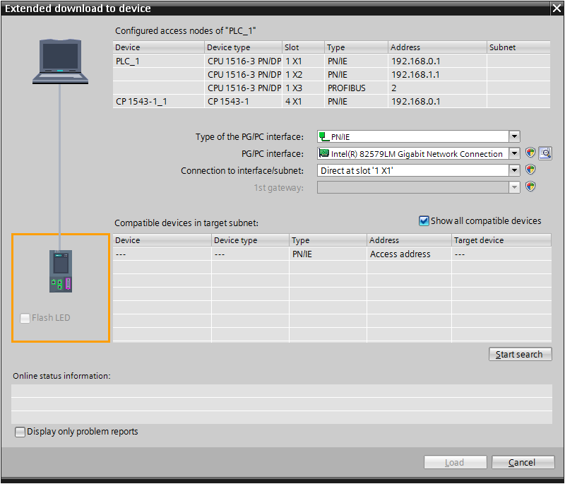

**Description**

The hardware configuration is available after inserting a new SIMATIC 1500 Station into the current S7 Project.

In this exercise, an initial Setpoint configuration will be downloaded to the PLC.

**Objectives**

Upon completion of this exercise, the student shall be able to:

* Download the Hardware Configuration to the PLC.

**Prerequisites**

The following prerequisites must be completed before this exercise is started:

* Exercise 1.1 has been completed.

### Download the hardware configuration to the PLC.

|  |
| --- |
| 1. Download the setpoint configuration to the PLC. 2. Select the CPU just added, either in the Device view or in the Project tree. 3. Initiate the download operation by clicking the download button  or by using the context menu to select “Download to device”, “Hardware”.      1. The Extended download to device dialog will appear since this is the first download to the new PLC and no connections have been defined as of yet. 2. Set the “Type of PG/PC interface” to PN/IE. 3. Set the “PG/PC” interface to match the Ethernet connection selected in the previous exercise. If you are unsure, consult your instructor. 4. Select the “Connection to interface/subnet” setting of “Direct at slot “1 X1” as we have no subnet in the project yet. 5. Click “Start search”. The software will attempt to locate the CPU online using the IP address for the CPU that is configured in the project.      1. Select the accessible CPU from the dialog and click “Load”. 2. In order to download to the PLC, the PLC IP address ***must fall into the same subnet as the Ethernet address of the port of the PG. If this is not the case, the Portal will prompt you to add an address automatically.***     Click on “Yes” to have the Portal add an alternate IP address to the Ethernet port on the PG. Note that this will NOT override current Windows settings for the port.   1. In Windows 7, the operating system will question the change, and the warning may well appear behind other windows. Check you taskbar for the Windows “shield” icon, open the dialog, and allow the change. The Portal will provide confirmation:      1. The Portal will compile the configuration again prior to downloading:      1. When the compile is done, the “Load preview” dialog appears giving an overview of what operation is to be performed:      1. Click “Load” to perform the download.      1. Once the download finishes, the “Load results” dialog will appear. Be sure to check “Start all”.      1. Click ‘”Finish” to complete the operation and restart the CPU.   RESULT: Your S7-1500 PLC should now be in the RUN mode with no errors.  *This completes the CH 1 Exercises.* |